**Docker Assignment**

1. **Create a docker network of type bridge with name hu-devops**

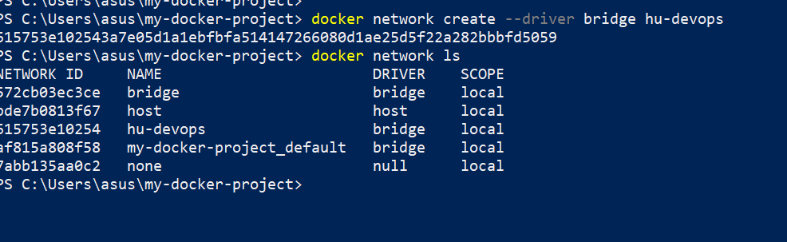

1. **Clone the flask code from repo, create docker file to run flask code on local host in network hu-devops**

Create a docker file

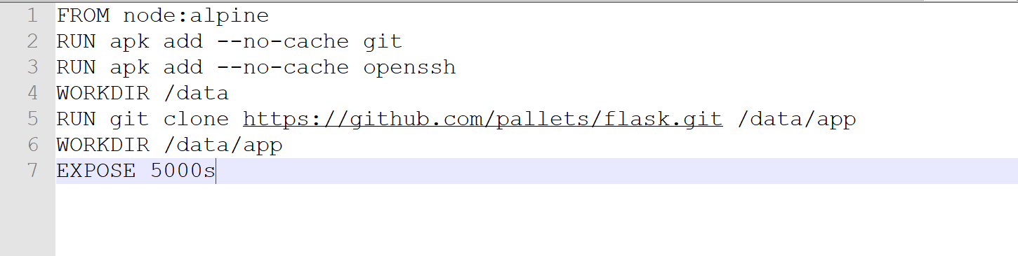

Build the docker file to create a flaskapp image using: docker build -t flask-app-image .

Also verify if image is successfully created using docker image command

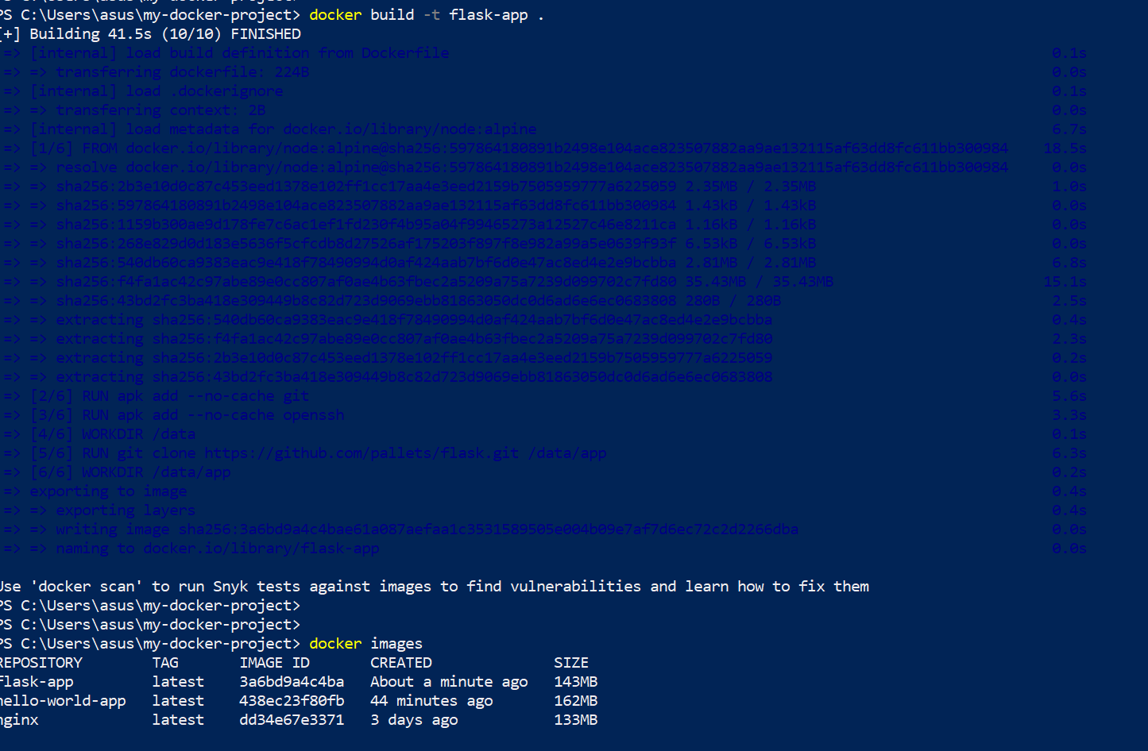

As seen above the flask-app image is created.

To run the container from flask image in hu-devops network run the command:

#docker run -d --name my-flask-app flask-app --network hu-devops

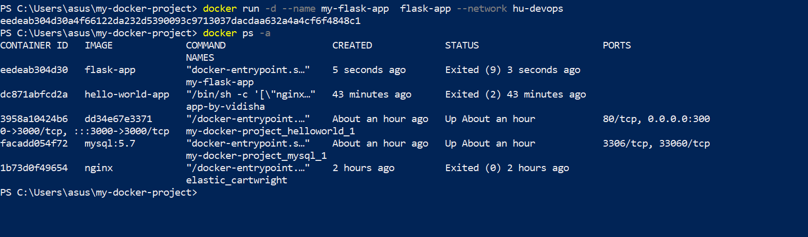

The flask container runs successfully on local host in hu-devops network

**3. Create a docker file to create a webserver container, when u hit the web server container at 80 it should redirect to application container in same network**

Create dockerfile

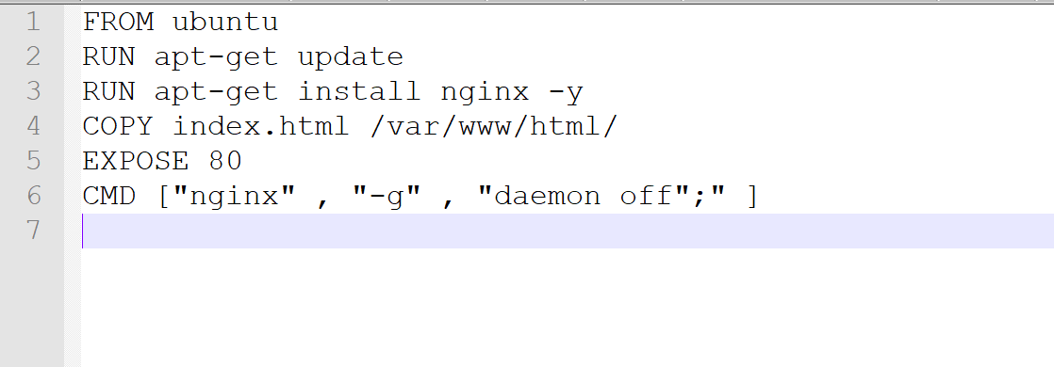

Create index.html

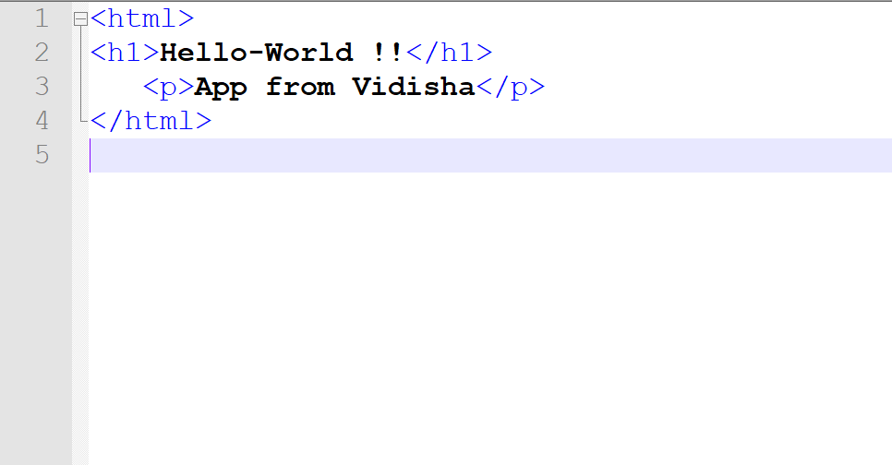

Run docker build command to build the docker file into a docker image

#docker build -t hello-world-app .

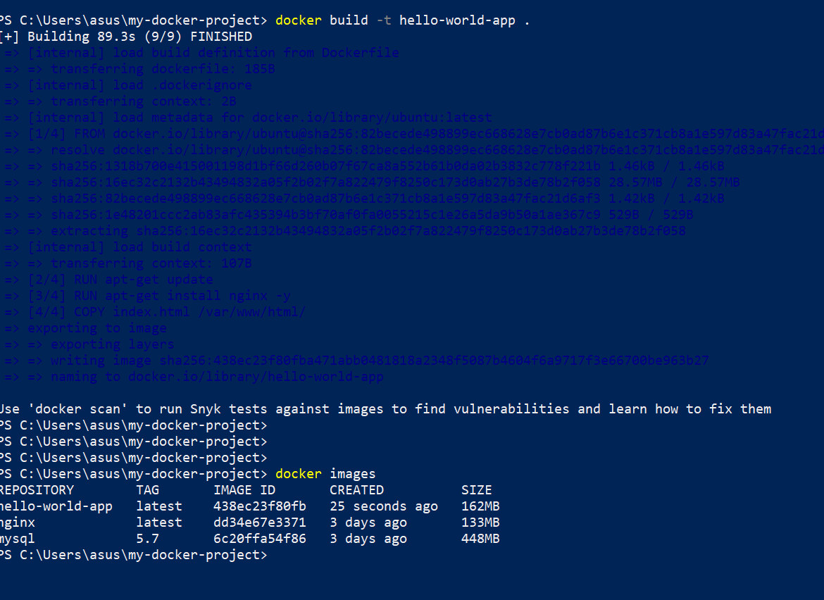

Also verify if image is successfully created or not like above

1. **Once the container is up and running the logs should be stored in log file**

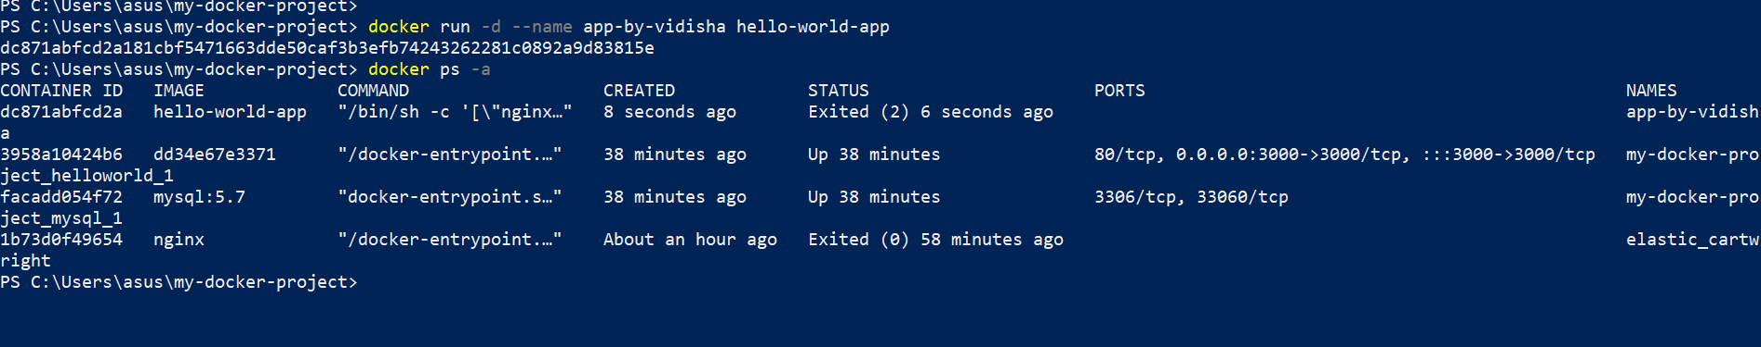

The container for the app is up and running.

Adding logs



1. **Document the complete process with Screenshosts**

done